编制人员 | 编制时间 | 修改内容
胡铭 | 2025.06.13 | 创建文档

需求部分
- 目的：提供字体Font Features at Runtime 设置最佳实践
- 阅读人群：程序

对接部分

结论与建议

结论
- 在相同条件下

最佳实践
- 应提前收集游戏中所有可能使用到的字符，将字符烘焙到字体图集中，避免运行时触发生成。

研发部分

Font Features at Runtime 设置

功能详解
Project Setting->TextMesh Pro

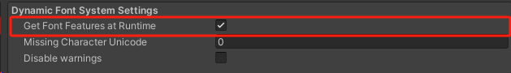

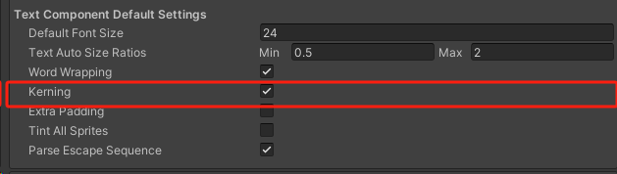
此功能会在增加新字时候获取新添加的字形的字距调整数据，在Text控件中显示字的时候能够自动字设置自定义间距。

流程解析
流程图

源码解析

增加新字时缓存字间距数据

TMP_FontAsset.cs

internal bool TryAddCharacterInternal(uint unicode, out TMP_Character character)
{
//...........................
if (TMP_Settings.getFontFeaturesAtRuntime)
RegisterFontAssetForFontFeatureUpdate(this);
//...........................
}

internal static void RegisterFontAssetForFontFeatureUpdate(TMP_FontAsset fontAsset)
{
int instanceID = fontAsset.instanceID;

if (k_FontAssets_FontFeaturesUpdateQueueLookup.Add(instanceID))
k_FontAssets_FontFeaturesUpdateQueue.Add(fontAsset);
}

internal static void UpdateFontFeaturesForFontAssetsInQueue()
{
int count = k_FontAssets_FontFeaturesUpdateQueue.Count;

for (int i = 0; i < count; i++)
k_FontAssets_FontFeaturesUpdateQueue[i].UpdateGlyphAdjustmentRecords();

if (count > 0)
{
k_FontAssets_FontFeaturesUpdateQueue.Clear();
k_FontAssets_FontFeaturesUpdateQueueLookup.Clear();
}
}

internal void UpdateGlyphAdjustmentRecords()
{
k_UpdateGlyphAdjustmentRecordsMarker.Begin();

GlyphPairAdjustmentRecord[] pairAdjustmentRecords = FontEngine.GetGlyphPairAdjustmentRecords(m_GlyphIndexList, out int recordCount);

// Clear newly added glyph list
m_GlyphIndexListNewlyAdded.Clear();

if (pairAdjustmentRecords == null || pairAdjustmentRecords.Length == 0)
{
k_UpdateGlyphAdjustmentRecordsMarker.End();
return;
}

if (m_FontFeatureTable == null)
m_FontFeatureTable = new TMP_FontFeatureTable();

for (int i = 0; i < pairAdjustmentRecords.Length && pairAdjustmentRecords[i].firstAdjustmentRecord.glyphIndex != 0; i++)
{
uint pairKey = pairAdjustmentRecords[i].secondAdjustmentRecord.glyphIndex << 16 | pairAdjustmentRecords[i].firstAdjustmentRecord.glyphIndex;

// Check if table already contains a pair adjustment record for this key.
if (m_FontFeatureTable.m_GlyphPairAdjustmentRecordLookupDictionary.ContainsKey(pairKey))
continue;

TMP_GlyphPairAdjustmentRecord record = new TMP_GlyphPairAdjustmentRecord(pairAdjustmentRecords[i]);

m_FontFeatureTable.m_GlyphPairAdjustmentRecords.Add(record);
m_FontFeatureTable.m_GlyphPairAdjustmentRecordLookupDictionary.Add(pairKey, record);
}

k_UpdateGlyphAdjustmentRecordsMarker.End();
}

FontEngine.bindings.cs
/// <summary>
/// Internal function used to retrieve GlyphPairAdjustmentRecords for the given glyph index.
/// </summary>
/// <param name="glyphIndex">Index of the target glyph.</param>
/// <param name="recordCount">Number of glyph pair adjustment records using this glyph.</param>
/// <returns>Array containing the glyph pair adjustment records.</returns>
internal static GlyphPairAdjustmentRecord[] GetGlyphPairAdjustmentRecords(uint glyphIndex, out int recordCount)
{
PopulatePairAdjustmentRecordMarshallingArray_from_GlyphIndex(glyphIndex, out recordCount);

if (recordCount == 0)
return null;

// Make sure marshalling array allocation is appropriate.
SetMarshallingArraySize(ref s_PairAdjustmentRecords_MarshallingArray, recordCount);

// Retrieve adjustment records already gathered by the GetPairAdjustmentRecordCount function.
GetGlyphPairAdjustmentRecordsFromMarshallingArray(s_PairAdjustmentRecords_MarshallingArray);

// Terminate last record to zero
s_PairAdjustmentRecords_MarshallingArray[recordCount] = new GlyphPairAdjustmentRecord();

return s_PairAdjustmentRecords_MarshallingArray;
}

int FontEngine::PopulatePairAdjustmentRecordMarshallingArray(const dynamic_array<unsigned int> &glyphIndexes, int &recordCount)
{
// Return error code if library or face is null.
if (m_Library == NULL || m_Face == NULL)
return 0x29; // Invalid library or font face.

if ((m_Face->face_flags & FACE_FLAG_KERNING) == 0)
return 0x08; // Missing Kern table.

int upSampling = m_Face->size->metrics.x_ppem / m_CurrentFaceSize;

m_PairAdjustmentRecords_MarshallingArray.clear_dealloc();

FT_Vector valueRecord;

int glyphIndexCount = glyphIndexes.size();

for (int i = 0; i < glyphIndexCount && glyphIndexes[i] != 0; i++)
{
unsigned int firstGlyphIndex = glyphIndexes[i];

for (int j = 0; j < glyphIndexCount && glyphIndexes[j] != 0; j++)
{
unsigned int secondGlyphIndex = glyphIndexes[j];

FT_Get_Kerning(m_Face, firstGlyphIndex, secondGlyphIndex, FT_KERNING_UNFITTED, &valueRecord);

if (valueRecord.x != 0 || valueRecord.y != 0)
{
AdjustmentRecord firstGlyphRecord = { firstGlyphIndex, ValueRecord { 0, 0, valueRecord.x / 64.0f / upSampling, valueRecord.y / 64.0f / upSampling } };
AdjustmentRecord secondGlyphRecord = { secondGlyphIndex, ValueRecord { 0, 0, 0, 0 } };

PairAdjustmentRecord record = { firstGlyphRecord, secondGlyphRecord, None };

m_PairAdjustmentRecords_MarshallingArray.push_back(record);
}
}
}

recordCount = m_PairAdjustmentRecords_MarshallingArray.size();

return 0;
}

void OnPreRenderObject()
{
if (m_havePropertiesChanged || m_isLayoutDirty)
{
TMP_FontAsset.UpdateFontFeaturesForFontAssetsInQueue();
}
}

Text控件中使用字间距

protected virtual Vector2 CalculatePreferredValues(ref float fontSize, Vector2 marginSize, bool isTextAutoSizingEnabled, bool isWordWrappingEnabled)
{
if (m_enableKerning)
{
TMP_GlyphPairAdjustmentRecord adjustmentPair;
uint baseGlyphIndex = m_cached_TextElement.m_GlyphIndex;

if (m_characterCount < totalCharacterCount - 1)
{
uint nextGlyphIndex = m_textInfo.characterInfo[m_characterCount + 1].textElement.m_GlyphIndex;
uint key = nextGlyphIndex << 16 | baseGlyphIndex;

if (m_currentFontAsset.m_FontFeatureTable.m_GlyphPairAdjustmentRecordLookupDictionary.TryGetValue(key, out adjustmentPair))
{
glyphAdjustments = adjustmentPair.m_FirstAdjustmentRecord.m_GlyphValueRecord;
characterSpacingAdjustment = (adjustmentPair.m_FeatureLookupFlags & FontFeatureLookupFlags.IgnoreSpacingAdjustments) == FontFeatureLookupFlags.IgnoreSpacingAdjustments ? 0 : characterSpacingAdjustment;
}
}

if (m_characterCount >= 1)
{
uint previousGlyphIndex = m_textInfo.characterInfo[m_characterCount - 1].textElement.m_GlyphIndex;
uint key = baseGlyphIndex << 16 | previousGlyphIndex;

if (m_currentFontAsset.m_FontFeatureTable.m_GlyphPairAdjustmentRecordLookupDictionary.TryGetValue(key, out adjustmentPair))
{
glyphAdjustments += adjustmentPair.m_SecondAdjustmentRecord.m_GlyphValueRecord;
characterSpacingAdjustment = (adjustmentPair.m_FeatureLookupFlags & FontFeatureLookupFlags.IgnoreSpacingAdjustments) == FontFeatureLookupFlags.IgnoreSpacingAdjustments ? 0 : characterSpacingAdjustment;
}
}

m_GlyphHorizontalAdvanceAdjustment = glyphAdjustments.m_XAdvance;
}
}

耗时分析

增加30个新字

开启功能
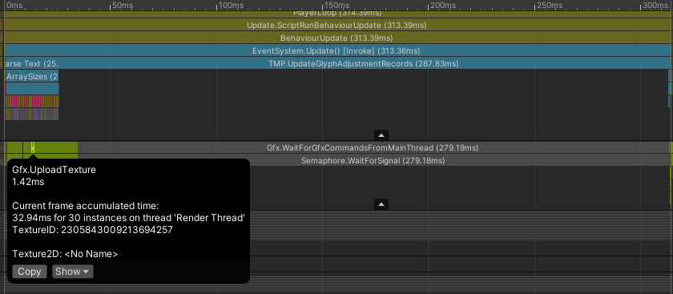

关闭功能

参考链接：
https://discussions.unity.com/t/how-does-the-get-font-features-at-runtime-work/764620
https://discussions.unity.com/t/version-1-4-1-preview-1-with-dynamic-sdf-for-unity-2018-3-now-available/730726

